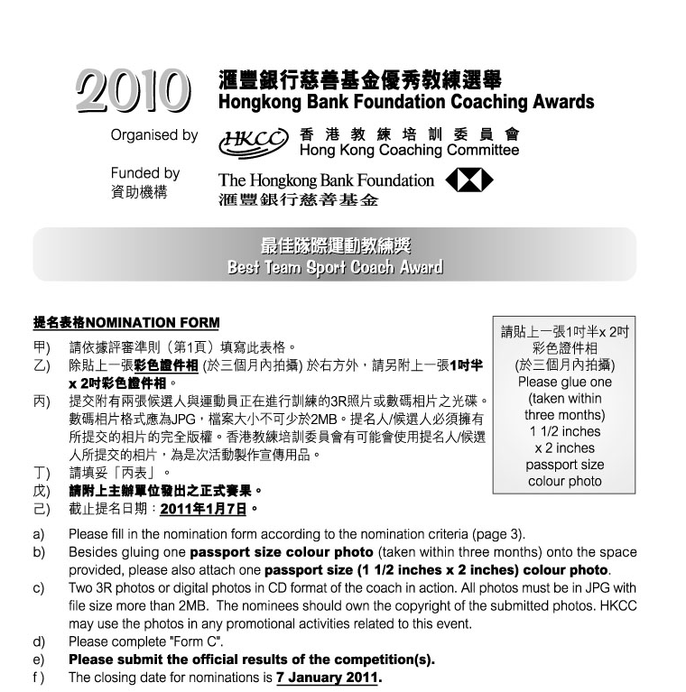

1. 候選人資料Nominee’s Personal Data :
 | 姓名Name: |  |  |  |  |  | (中Chinese) |  |  |  |  |  |  |  |  | (英English)
 | 出生日期Date of Birth: |  |  |  |  |  |  |  |  | 地址Address:
 |  |  |  |  |  |  |  |  |  |  |  |  |  |  |  | (英English)
 | 辦公室電話Business telephone: |  |  |  |  |  |  |  |  |  |  | 手提電話Mobile :
 | 傳真Facsimile: |  |  |  |  |  |  |  |  |  | 電郵 E-mail:
 | 職業Occupation: |  |  |  |  |  |  |  | (中Chinese) |  |  |  |  |  |  | (英English)
 | 總會職銜Position with your Association:
 |  |  |  |  |  | (中Chinese) |  |  |  |  |  |  |  |  |  | (英English)
 | 所獲取之認可教練級別Level of coach accreditation:

2. 提名人Nominated by :
 | 體育總會National Sports Association:
 | 提名人姓名Name: |  |  |  |  |  |  |  |  | 職銜Position:
 | 地址Address:
 | 辦公室電話Business telephone: |  |  |  |  |  |  |  |  |  |  | 手提電話Mobile:
 | 傳真Facsimile: |  |  |  |  |  |  | 電郵E-mail:
 | 簽署Signature:
 | 日期Date: |  |  |  |  |  |  |  | 總會印章Association’s chop:
 | 如未能在截止提名日期即2011年1月7日或之前提供以下資料，獲提名教練之申請將不獲接納。If the following information cannot be provided on or before 7 January 2011, the application will not be considered.
 |  | 已填妥提名表格 Duly completed nomination form.
 |  | 已附上兩張候選人與運動員正在進行訓練的3R彩色照片或數碼相片之光碟Enclosed two 3R colour photos or digital photos in CD format of the coach in action.
 |  | 已附上「丙表」Enclosed “Form C”.
 |  | 已附上主辦單位發出之正式賽果Enclosed the official results of the competition(s).
 |  | 已於報名表上貼上一張三個月內拍攝的彩色證件相GLUED one recent (taken within three months) passport size colour photo onto the nomination form.
 |  | 已附上一張三個月內拍攝的彩色證件相ENCLOSED one recent (taken within three months) passport size colour photo.

丙表 Form C 「最佳隊際運動教練獎」“Best Team Sport Coach Award”
候選人姓名:  Name of Nominee: |  | 體育總會:  NSA:

- 賽事的有關資料 Related information of the competition(s)

* 請把每項賽事列於獨立表格上(可自行複印表格)，及呈交主辦單位發出之正式賽果並用螢光筆突顯候選人的成績。
Please list EACH event on a separate form (Forms can be photocopied) and submit full official results of the competition(s) and highlight the nominee’s results.
 | 賽事全名 Official name of the competition:
 | (中Chinese)
 | (英English)
 | 日期Date: |  |  |  |  |  |  |  | 地點Venue:
 | 參賽項目Event(s):
 | (中Chinese)
 | (英English)
 | 請列明Please specify |  |  |  | 成人Senior |  |  |  |  | / 青少年Junior
 |  |  |  |  | 男子Men |  |  |  |  | / 女子 Women
 | 組別Category: |  | (中Chinese)
 |  |  | (英English)
 | 運動員姓名Name(s) of athlete(s): |  |  |  |  |  | (中Chinese)
 |  |  |  |  |  |  | (英English)
 | 運動員居港年期Athletes’ years of residence in Hong Kong:
 | 訓練日期Training Period : 由From: |  |  |  |  |  |  |  |  |  | 至to:
 |  |  |  |  |  |  | (月month) |  |  |  |  |  | (月month)
 | 所獲名次Position attained:
 | 參賽項目的國家總數Total no. of participating countries in the event:
 | 參加該項目的隊伍數目No. of teams in the event:

丙表 Form C 「最佳隊際運動教練獎」”Best Team Sport Coach Award”

- 參與教練工作經驗
Coaching experience

- 列舉候選人所屬的運動隊伍的表現及該教練對其運動員的短期及長期貢獻
Please provide detailed information on the nominee’s short-term and long-term contribution to the performance of the team/athletes

