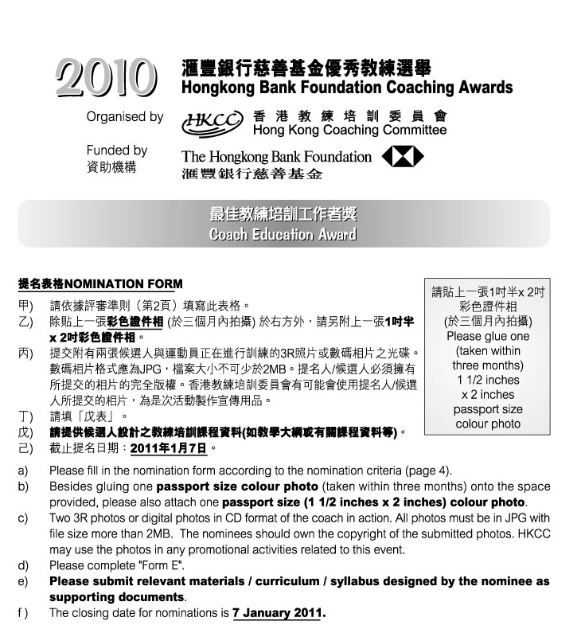

1. 候選人資料Nominee’s Personal Data :
 | 姓名Name: |  |  |  |  |  |  |  |  | (中Chinese) |  |  |  |  |  |  |  |  |  |  |  |  |  | (英English)
 | 出生日期Date of Birth: |  |  |  |  |  |  |  |  |  |  |  |  |  | 地址Address:
 |  |  |  |  |  |  |  |  |  |  |  |  |  |  |  |  |  |  |  |  |  |  |  | (英English)
 | 辦公室電話Business telephone: |  |  |  |  |  |  |  |  |  |  |  |  |  |  |  |  |  |  | 手提電話Mobile :
 | 傳真Facsimile: |  |  |  |  |  |  |  |  |  |  |  |  |  |  |  |  | 電郵 E-mail:
 | 職業Occupation: |  |  |  |  |  |  |  |  |  |  |  | (中Chinese) |  |  |  |  |  |  |  |  |  |  | (英English)
 | 總會職銜Position with your Association:
 |  |  |  |  |  |  |  |  | (中Chinese) |  |  |  |  |  |  |  |  |  |  |  |  |  |  | (英English)

 | 所獲取之認可教練級別Level of coach accreditation:
2. 提名人Nominated by :
 | 體育總會National Sports Association:
 | 提名人姓名Name: |  |  |  |  |  |  |  | 職銜Position:
 | 地址Address:
 | 辦公室電話Business telephone: |  |  |  |  |  |  |  |  | 手提電話Mobile:
 | 傳真Facsimile: |  |  |  |  |  |  |  | 電郵E-mail:
 | 簽署Signature:
 | 日期Date: |  |  |  |  |  |  | 總會印章Association’s chop:
 | 如未能在截止提名日期即2011年1月7日或之前提供以下資料，獲提名教練之申請將不獲接納。If the following information cannot be provided on or before 7 January 2011, the application will not be considered.
 |  | 已填妥提名表格 Duly completed nomination form.
 |  | 已附上兩張候選人與運動員正在進行訓練的3R彩色照片或數碼相片之光碟Enclosed two 3R colour photos or digital photos in CD format of the coach in action.
 |  | 已附上「戊表」Enclosed “Form E”.
 |  | 已於報名表上貼上一張三個月內拍攝的彩色證件相GLUED one recent (taken within three months) passport size colour photo onto the nomination form.
 |  | 已附上一張三個月內拍攝的彩色證件相ENCLOSED one recent (taken within three months) passport size colour photo.
 |  | 已附上候選人設計之教練培訓課程資料(如教學大綱或有關課程資料等) Enclosed relevant materials/curriculum/syllabus designed by the nominee.

戊表 Form E 「最佳教練培訓工作者獎」“Coach Education Award”
候選人姓名:  Name of Nominee: |  | 體育總會:  NSA:

請列舉實際例子及數據，說明候選人過往在教練培訓工作上的貢獻。
Please provide facts and figures to support the nominee’s contribution to coach education.

參與教練工作經驗
Coaching experience

請列舉實際例子及數據闡述候選人在教練培訓工作的貢獻 (請附上有關資料/課程/教學大綱等；及請列明接受相關課程的教練人數)
Contribution to coach education with supporting facts and figures (Please submit relevant materials/curriculum/syllabus, etc; and please provide the number of coaches being taught.)

如適合，請列舉過往五年在推動教練參與教練級別評定計劃的有關數據及附上有關資料
If appropriate, please provide figures for the past five years on encouraging coaches to participate in the Coach Accreditation Programme. Please also attach relevant documents.

年份  Year |  | 參加人數 No. of Coaches
 |  | 香港教練培訓委員會的教練級別評定計劃  CAP Courses by HKCC | 體育總會的認可教練課程  Accredited Coaching Courses by NSA
2010
2009
2008
2007
2006
其他相關數據
Other relevant figures

對教練培訓工作的抱負和理想
Vision and goals towards coach education

