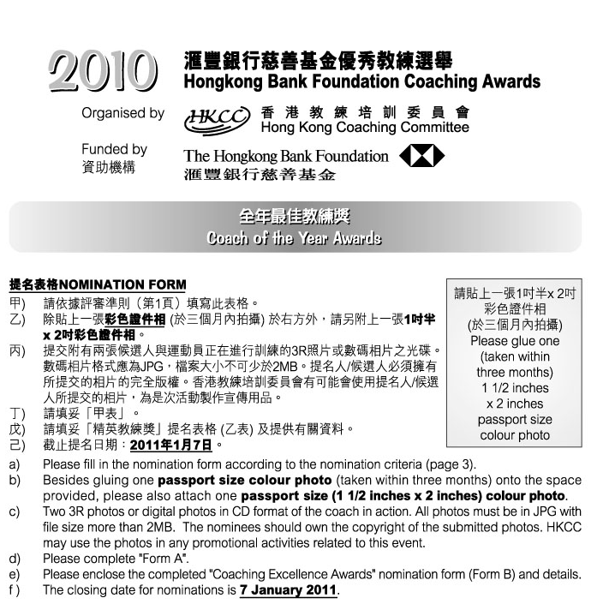

1. 候選人資料Nominee’s Personal Data :
 | 姓名Name: |  |  |  |  | (中Chinese) |  |  |  |  |  |  |  |  |  | (英English)
 | 出生日期Date of Birth: |  |  |  |  |  |  |  | 地址Address:
 |  |  |  |  |  |  |  |  |  |  |  |  |  |  |  | (英English)
 | 辦公室電話Business telephone: |  |  |  |  |  |  |  |  |  |  | 手提電話Mobile :
 | 傳真Facsimile: |  |  |  |  |  |  |  |  | 電郵 E-mail:
 | 職業Occupation: |  |  |  |  |  |  | (中Chinese) |  |  |  |  |  |  |  | (英English)
 | 總會職銜Position with your Association:
 |  |  |  |  |  | (中Chinese) |  |  |  |  |  |  |  |  |  | (英English)

2. 選舉組別(請以X顯示參選組別)Category of Award(s) (Please put “X”to indicate the nominating category):
 |  |  | 個人項目 – 高級組 |  |  |  |  | Senior athletes – individual sport
 |  |  | 團體項目 – 高級組 |  |  |  |  | Senior athletes – team event
 |  |  | 個人項目 – 青少年組* |  |  |  |  | Junior athletes* – individual sport
 |  |  | 團體項目 – 青少年組* |  |  |  |  | Junior athletes* – team event
*請列出貴體育總會界定青少年組的具體準則。
Please provide the official definition of a Junior according to your National Sports Association.
3. 提名人Nominated by :
 | 體育總會National Sports Association:
 | 提名人姓名Name: |  |  |  |  |  |  |  |  | 職銜Position:
 | 地址Address:
 | 辦公室電話Business telephone: |  |  |  |  |  |  |  |  |  | 手提電話Mobile:
 | 傳真Facsimile: |  |  |  |  |  |  |  |  | 電郵E-mail:
 | 簽署Signature:
 | 日期Date: |  |  |  |  |  |  |  | 總會印章Association’s chop:
 | 如未能在截止提名日期即2011年1月7日或之前提供以下資料，獲提名教練之申請將不獲接納。If the following information cannot be provided on or before 7 January 2011, the application will not be considered.
 |  | 已填妥提名表格 Duly completed nomination form.
 |  | 已附上兩張候選人與運動員正在進行訓練的3R彩色照片或數碼相片之光碟 Enclosed two 3R colour photos or digital photos in CD format of the coach in actions.
 |  | 已附上「甲表」 Enclosed “Form A”.
 |  | 已附上「精英教練獎」有關資料及表格（乙表）Enclosed the completed “Coaching Excellence Awards” nomination form (Form B) and details.
 |  | 已於報名表上貼上一張三個月內拍攝的彩色證件相GLUED one recent (taken within three months) passport size colour photo onto the nomination form.
 |  | 已附上一張三個月內拍攝的彩色證件相ENCLOSED one recent (taken within three months) passport size colour photo.

甲表 Form A 「全年最佳教練獎」“Coach of the Year Awards”
候選人姓名:  Name of Nominee: |  | 體育總會:  NSA:

請列舉實際例子及數據，說明候選人具備以下條件 :
Please support your nomination by commenting in details, giving SPECIFIC examples and providing facts and figures whenever possible on the nominee’s ability in the following aspects:

運動員成績的穩定性
Consistency of performance

培育新秀的主動性
Initiative in developing potential athletes

提升運動員的積極態度
Improvement of athletes’ work ethics

提升團隊間的合作精神
Co-operation among squad members

其他
Others

