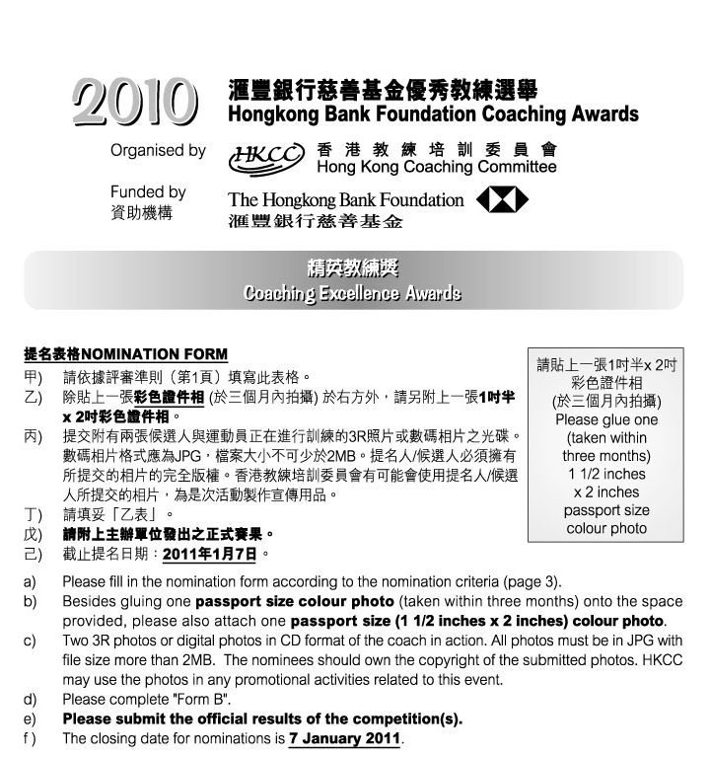

1. 候選人資料Nominee’s Personal Data :
 | 姓名Name: |  |  |  |  |  |  |  | (中Chinese) |  |  |  |  |  |  |  |  |  |  |  |  |  | (英English)
 | 出生日期Date of Birth: |  |  |  |  |  |  |  |  |  |  | 地址Address:
 |  |  |  |  |  |  |  |  |  |  |  |  |  |  |  |  |  |  |  |  |  |  | (英English)
 | 辦公室電話Business telephone: |  |  |  |  |  |  |  |  |  |  |  |  |  |  | 手提電話Mobile :
 | 傳真Facsimile: |  |  |  |  |  |  |  |  |  |  |  |  | 電郵 E-mail:
 | 職業Occupation: |  |  |  |  |  |  |  |  |  | (中Chinese) |  |  |  |  |  |  |  |  |  |  |  | (英English)
 | 總會職銜Position with your Association:
 |  |  |  |  |  |  |  |  | (中Chinese) |  |  |  |  |  |  |  |  |  |  |  |  |  | (英English)
 | 所獲取之認可教練級別Level of coach accreditation:
2. 提名人Nominated by :
 | 體育總會National Sports Association:
 | 提名人姓名Name: |  |  |  |  |  |  |  |  |  |  |  | 職銜Position:
 | 地址Address:
 | 辦公室電話Business telephone: |  |  |  |  |  |  |  |  |  |  |  |  |  |  | 手提電話Mobile:
 | 傳真Facsimile: |  |  |  |  |  |  |  |  |  |  |  | 電郵E-mail:
 | 簽署Signature:
 | 日期Date: |  |  |  |  |  |  |  |  |  | 總會印章Association’s chop:
 | 如未能在截止提名日期即2011年1月7日或之前提供以下資料，獲提名教練之申請將不獲接納。If the following information cannot be provided on or before 7 January 2011, the application will not be considered.
 |  | 已填妥提名表格 Duly completed nomination form.
 |  | 已附上兩張候選人與運動員正在進行訓練的3R彩色照片或數碼相片之光碟Enclosed two 3R colour photos or digital photos in CD format of the coach in action.
 |  | 已附上「乙表」Enclosed “Form B”.
 |  | 已附上主辦單位發出之正式賽果Enclosed the official results of the competition(s).
 |  | 已於報名表上貼上一張三個月內拍攝的彩色證件相GLUED one recent (taken within three months) passport size colour photo onto the nomination form.
 |  | 已附上一張三個月內拍攝的彩色證件相ENCLOSED one recent (taken within three months) passport size colour photo.

乙表 Form B 「精英教練獎」“Coaching Excellence Awards”
候選人姓名: |  | 體育總會:
Name of Nominee: |  | NSA:

- 賽事的有關資料 Related information of the competition(s)

* 請把每項賽事列於獨立表格上(可自行複印表格)，及呈交主辦單位發出之正式賽果並用螢光筆突顯候選人的成績。
Please list EACH event on a separate form (Forms can be photocopied) and submit the official results of the competition(s) and highlight the nominee’s results.
 | 賽事全名 Official name of the competition:
 | (中Chinese)
 | (英English)
 | 日期Date: |  |  |  |  |  |  |  | 地點Venue:
 | 參賽項目Event(s):
 | (中Chinese)
 | (英English)
 | 請列明Please specify |  |  |  | 隊際Team |  |  |  |  | / 個人 Individual
 |  |  |  |  | 成人Senior |  |  |  |  | / 青少年Junior
 |  |  |  |  | 男子Men |  |  |  |  | / 女子 Women
 | 組別Category: |  | (中Chinese)
 |  |  | (英English)
 | 運動員姓名Name(s) of athlete(s): |  |  |  |  |  | (中Chinese)
 |  |  |  |  |  |  | (英English)
 | 運動員居港年期Athlete’s years of residence in Hong Kong:
 | 訓練日期Training Period : 由From: |  |  |  |  |  |  |  |  |  | 至to:
 |  |  |  |  |  |  | (月month) |  |  |  |  |  | (月month)
 | 所獲名次Position attained:
 | 參賽項目的國家總數Total no. of participating countries in the event:
 | 參加該項目的人次 / 隊伍數目No. of participants/ teams in the event:

