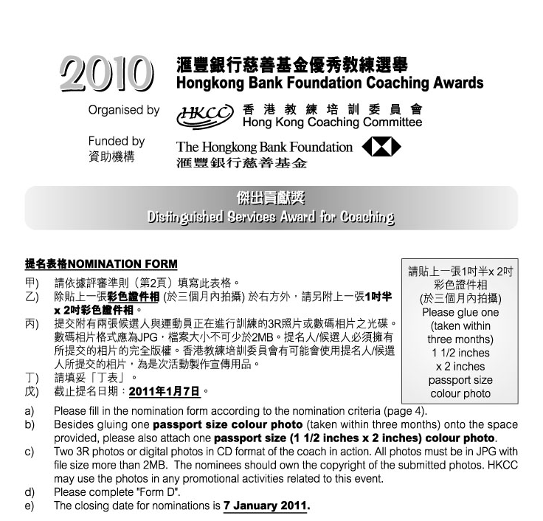

1. 候選人資料Nominee’s Personal Data :
 | 姓名Name: |  |  |  |  |  |  | (中Chinese) |  |  |  |  |  |  |  | (英English)
 | 出生日期Date of Birth: |  |  |  |  |  |  |  |  |  | 地址Address:
 |  |  |  |  |  |  |  |  |  |  |  |  |  |  |  | (英English)
 | 辦公室電話Business telephone: |  |  |  |  |  |  |  |  |  |  |  | 手提電話Mobile :
 | 傳真Facsimile: |  |  |  |  |  |  |  |  |  |  | 電郵 E-mail:
 | 職業Occupation: |  |  |  |  |  |  |  |  | (中Chinese) |  |  |  |  |  | (英English)
 | 總會職銜Position with your Association:
 |  |  |  |  |  |  |  | (中Chinese) |  |  |  |  |  |  |  | (英English)
 | 從事教練工作之服務年資Years of coaching services in the sports community:

 | 候選人所獲取之認可教練級別Nominee’s level of coach accreditation:
2. 提名人Nominated by :
 | 體育總會National Sports Association:
 | 提名人姓名Name: |  |  |  |  |  |  |  | 職銜Position:
 | 地址Address:
 | 辦公室電話Business telephone: |  |  |  |  |  |  |  |  | 手提電話Mobile:
 | 傳真Facsimile: |  |  |  |  |  |  |  | 電郵E-mail:
 | 簽署Signature:
 | 日期Date: |  |  |  |  |  |  | 總會印章Association’s chop:
 | 如未能在截止提名日期即201!年1月7日或之前提供以下資料，獲提名教練之申請將不獲接納。If the following information cannot be provided on or before 7 January 2011, the application will not be considered.
 |  | 已填妥提名表格 Duly completed nomination form.
 |  | 已附上兩張候選人與運動員正在進行訓練的3R彩色照片或數碼相片之光碟Enclosed two 3R colour photos or digital photos in CD format of the coach in action.
 |  | 已附上「丁表」Enclosed “Form D”.
 |  | 已於報名表上貼上一張三個月內拍攝的彩色證件相GLUED one recent (taken within three months) passport size colour photo onto the nomination form.
 |  | 已附上一張三個月內拍攝的彩色證件相ENCLOSED one recent (taken within three months) passport size colour photo.

丁表 Form D 「傑出貢獻獎」“Distinguished Services Award for Coaching”
候選人姓名:  Name of Nominee: |  | 體育總會:  NSA:

請列舉實際例子及數據，說明候選人具備以下條件 :
Please support your nomination by commenting in details, giving SPECIFIC examples and providing facts and figures whenever possible on the nominee’s ability in the following aspects:

參與教練工作經驗
Coaching experience

提高運動員個人或隊伍在國際賽事上的運動水平 (請提供參賽項目的國家總數)
Improve the performance of a team or an individual at the international level (please provide the number of participating countries competed in the event)

關心運動員全面的發展
Demonstrate concern for the all-round development of the athlete(s)

尊重裁判、對手及家長，並持公平競技的原則
Demonstrate respect for officials, opponents and parents and espouse fair play

對教練專業知識的追求
Strive to improve his/her knowledge and expertise in coaching

其他
Others

