
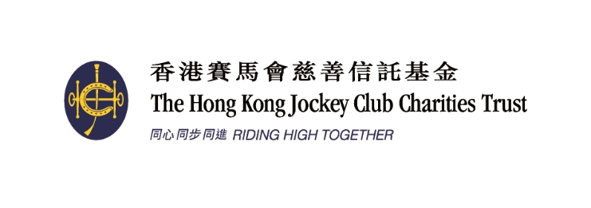
Organised by 主辦機構
Funded by 捐助機構:

2016賽馬會香港優秀教練選舉
2016 Jockey Club Hong Kong Coaching Awards

全年最佳教練獎
Coach of the Year Awards

提名表格 NOMINATION FORM
請貼上一張1吋半 x 2吋彩色證件相 (於三個月內拍攝)
Please glue one (taken within three months) 1.5 inches x 2 inches passport size colour photo
甲）請依據提名準則填寫此表格
乙）除貼上一張彩色證件相（於三個月內拍攝）於右方外，請另附上一張 1吋半 x 2吋彩色證件相。
丙）提交附有兩張候選人與運動員正在進行訓練的 3R照片、數碼相片的光碟。數碼相片格式應為 JPG，檔案大小不可少於 2MB (300dpi)。提名人╱候選人必須擁有所提交的相片的完全版權。香港教練培訓委員會有可能會使用提名人╱候選人所提交的相片為是次活動製作宣傳用品。
丁）請填妥「甲表」。
戊）請填妥「精英教練獎」提名表格（乙表）及提供有關資料。
己）截止提名日期 : 2016年12月31日。

- Please fill in the nomination form according to the nomination criteria (page 3).
- Besides gluing one passport size colour photo (taken within three months) onto the space provided, please also attach one passport size (1.5 inches x 2 inches) colour photo.
- Two 3R photos or digital photos in CD format of the coach in action. All photos must be in JPG with file size more than 2MB (300dpi). The nominees should own the copyright of the submitted photos. HKCC may use the photos in any promotional activities related to this event.
- Please complete “Form A”.
- Please enclose the completed “Coaching Excellence Awards” nomination form (Form B) and details.
- The closing date for nominations is 31 December 2016.

1. 候選人資料Nominee’s Personal Data:
 | 姓名Name: |  |  |  |  | (中Chinese) |  |  |  |  |  |  |  | (英English)
 | 出生日期Date of Birth: |  |  |  |  |  |  |  | 電郵 E-mail:
 | 地址Address:
 |  |  |  |  |  |  |  |  |  |  |  |  |  | (英English)
 | 辦公室電話Business telephone: |  |  |  |  |  |  |  |  |  | 手提電話Mobile:
 | 職業Occupation: |  |  |  |  |  |  | (中Chinese) |  |  |  |  |  | (英English)
 | 總會職銜Position with your Association:
 |  |  |  |  |  | (中Chinese) |  |  |  |  |  |  |  | (英English)

2. 選舉組別(請以X顯示參選組別)Category of Award(s) (Please put “X”to indicate the nominating category):
 |  | 個人項目 – 高級組 | Senior athletes – individual event
 |  | 團體項目 – 高級組 | Senior athletes – team event
 |  | 個人項目 – 青少年組 | Junior athletes* – individual event
 |  | 團體項目 – 青少年組 | Junior athletes* – team event
*請列出貴體育總會界定青少年組的具體準則。
Please provide the official definition of a Junior according to your National Sports Association.

3. 提名人Nominated by:
 | 體育總會National Sports Association:
 | 提名人姓名Name: |  |  |  |  |  |  | 職銜Position:
 | 地址Address:
 | 辦公室電話Business telephone: |  |  |  |  |  |  |  | 手提電話Mobile:
 | 傳真Facsimile: |  |  |  |  |  |  | 電郵E-mail:
 | 簽署Signature:
 | 日期Date: |  |  |  |  |  | 總會印章Association’s chop:
如未能在截止提名日期即2016年12月31日或的前提供以下資料，申請將不獲接納。
If the following information cannot be provided on or before 31 December 2016, the application will not be considered.
 |  | 已填妥提名表格 Duly completed nomination form.
 |  | 已附上兩張候選人與運動員正在進行訓練的3R彩色照片或數碼相片的光碟 Enclosed two 3R colour photos or digital photos in CD format of the coach in action.
 |  | 已附上「甲表」 Enclosed “Form A”.
 |  | 已附上「精英教練獎」有關資料的表格（乙表）Enclosed the completed “Coaching Excellence Awards” nomination form (Form B) and details.
 |  | 已於報名表上貼上一張三個月內拍攝的彩色證件相GLUED one recent (taken within three months) passport size colour photo onto the nomination form.
 |  | 已附上一張三個月內拍攝的彩色證件相ENCLOSED one recent (taken within three months) passport size colour photo.

甲表 Form A 「全年最佳教練獎」“Coach of the Year Awards”
候選人姓名:  Name of Nominee: |  | 體育總會:  NSA:

請列舉實際例子的數據，說明候選人具備以下條件 :
Please support your nomination by commenting in details, giving SPECIFIC examples and providing facts and figures whenever possible on the nominee’s ability in the following aspects:

運動員成績的穩定性
Consistency of performance

培育新秀的主動性
Initiative in developing potential athletes

提升運動員的積極態度
Improvement of athletes’ work ethics

提升團隊間的合作精神
Co-operation among squad members

其他
Others

* 如空位不敷填寫，可按以上格式於另頁詳列有關資料，隨提名表格附上。
If there is insufficient space, please give details in accordance to the specified format on a separate sheet to be attached to the nomination form.

