
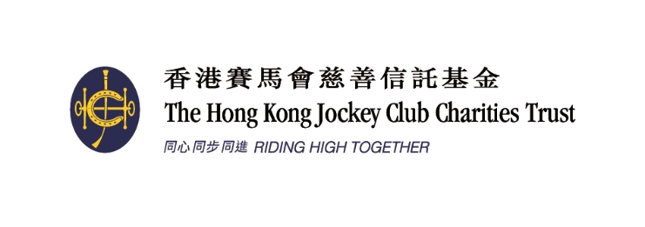
Organised by 主辦機構
Funded by 捐助機構:

2017賽馬會香港優秀教練選舉
2017 Jockey Club Hong Kong Coaching Awards

全年最佳教練獎
Coach of the Year Awards

提名表格 NOMINATION FORM
請貼上一張1吋半 x 2吋彩色證件相 (於三個月內拍攝)
Please fix 1.5 inches x 2 inches passport size colour photo (taken within three months)
colour photo
- 填寫此表格前請細閱提名準則。
- 除貼上一張彩色證件相 (於三個月內拍攝) 於右方外，請另附上一張1吋半 x 2吋彩色證件相。
- 提交附有兩張候選人與運動員正進行訓練的3R相片或數碼相片的光碟。數碼相片格式應為JPG，檔案大小不可少於2MB (300dpi)。提名人/候選人必須擁有所提交相片的版權。香港教練培訓委員會將使用所提交的相片為是次活動作宣傳。
- 截止提名日期 : 二零一七年十二月三十一日。如未能在截止提名日期或之前將填妥的表格及所需資料一併交回，申請將不獲接納。

    - Please read the nomination criteria before filling in the nomination form.
    - Besides fixing one passport size colour photo (taken within three months) onto the space provided, please also attach one passport size (1.5 inches x 2 inches) colour photo.
    - Please submit two colour photos in either 3R print format or digital format in CD, showing the interaction between the nominee and athlete(s) at training. All photos must be in JPG with file size not less than 2MB (300dpi). The nominator/nominee should own the copyright of the photos. HKCC may use the photos in promotional activities related to this event.
    - The closing date for nominations is 31 December 2017. If the form is not completed and submitted with required document/information on or before the closing date, the application will not be considered.

1. 候選人資料Particulars of Nominee:
 |  | 姓名Name: |  |  |  |  |  |  |  | (中Chinese) |  |  |  |  |  |  |  |  |  |  |  |  |  |  |  |  | (英English)
 |  | 出生日期Date of Birth: |  |  |  |  |  |  |  |  |  |  |  | 性別 Gender*: |  |  |  |  |  |  | 男 Male / 女 Female
 |  | 地址Address:
 |  |  |  |  |  |  |  |  |  |  |  |  |  |  |  |  |  |  |  |  |  |  |  |  |  |  | (英English)
 |  | 電話Tel.: |  |  |  |  |  |  |  |  |  | (公司Office) |  |  |  |  |  |  |  |  |  |  |  |  |  |  | (手提Mobile)
 |  | 傳真Facsimile: |  |  |  |  |  |  |  |  |  |  |  |  |  |  | 電郵 E-mail:
 |  | 職業Occupation.: |  |  |  |  |  |  |  |  |  |  | (中Chinese) |  |  |  |  |  |  |  |  |  |  |  |  |  |  | (英English)
 |  | 總會職銜Position at Association:
 |  |  |  |  |  |  |  |  | (中Chinese) |  |  |  |  |  |  |  |  |  |  |  |  |  |  |  |  |  |  | (英English)
 | * 請刪除不適用者 Please delete as appropriate
2. 選舉組別 (請以X顯示參選組別) Category of Award(s) (Please put “X” to indicate the nominating category):
 |  | 個人項目 – 高級組 | Senior athletes – individual event
 |  | 團體項目 – 高級組 | Senior athletes – team event
 |  | 個人項目 – 青少年組 | Junior athletes* – individual event
 |  | 團體項目 – 青少年組 | Junior athletes* – team event
*請列出所屬體育總會界定青少年組的具體準則。
Please state the National Sports Association’s official criteria of a Junior.

3. 提名人資料Particulars of Nominator:
 |  | 體育總會National Sports Association:
 |  | 姓名Name: |  |  |  |  |  |  |  |  |  |  |  |  |  | 職銜Position:
 |  | 地址Address:
 |  | 電話Tel.: |  |  |  |  |  |  |  |  |  | (公司Office) |  |  |  |  |  |  |  |  |  |  |  |  |  |  | (手提Mobile)
 |  | 傳真Facsimile: |  |  |  |  |  |  |  |  | 電郵E-mail:
 |  | 簽署Signature: |  |  |  |  |  |  |  |  |  |  |  |  | 總會印章Association’s Chop:
 |  | 日期Date:

4. 提名理據 Justification of the Nomination

請列舉實際例子及數據，說明候選人具備以下條件 :
Please support your nomination by commenting in details, providing cases and figures on the nominee’s capability in the following aspects:

運動員成績的穩定性
Maintaining the consistency of athletes’ performance

培育新秀的主動性
Initiative in nurturing potential athletes

提升運動員的積極態度
Facilitating the positive attitude of athletes

提升團隊間的合作精神
Enhancing the co-operation among squad members

其他 (請列明)
Others (Please specify)

如空位不敷填寫，可按以上格式於另頁詳列有關資料，隨提名表格附上。
If there is insufficient space, please give details by adopting the above format on a separate sheet and attach it to the nomination form.

5. 聲明 Declaration
本人謹以此聲明表格所填寫的資料均真確無誤，並明白如有任何虛報資料將有可能被取消參選資格，即使已獲頒發之獎項亦有可能會被取消。
I declare that all information provided in the application is true and accurate. I understand that non-conformity with the submitted information without valid reasons, breach of terms might result in cessation of the nomination/award.

提名人簽署Signature of nominator: ______________________
日期 Date: _____________________

