
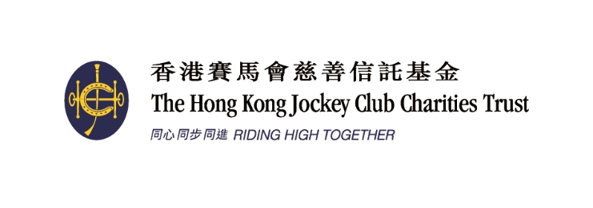
Organised by 主辦機構
Funded by 捐助機構:

2018賽馬會香港優秀教練選舉
2018 Jockey Club Hong Kong Coaching Awards

全年最佳教練獎提名表格
Coach of the Year Awards Nomination Form

填寫此表格前請細閱提名準則 Please read the nomination criteria carefully before filling in this form
截止提名日期 : 二零一九年一月十六日 Closing date for nominations: 16 January 2019
 | 候選人資料Particulars of Nominee:
 | 英文姓名 Name in English: |  |  |  |  |  |  |  |  | (姓Surname) |  |  |  |  |  |  |  | (名Other Name)
 | 中文姓名 Name in Chinese: |  |  |  |  |  |  |  |  |  |  |  |  | 請貼上一張1吋半 x 2吋彩色證件相 (於三個月內拍攝)  Please fix a 1.5 inches x 2 inches passport colour photo (taken within three months)
 | 出生日期 Date of Birth: |  |  |  |  |  |  |  |  |  | (DD/MM/YY)
 | 性別 Gender: | □ | 男 Male |  |  | □ | 女 Female
 | 電話Tel.: |  |  |  |  |  |  |  |  |  |  | (公司Office)
 |  |  |  |  |  |  |  |  |  |  |  | (手提Mobile)
 | 傳真Facsimile:
 | 電郵 E-mail:
 | 地址Address:
 |  |  |  |  |  |  |  |  |  |  |  |  |  |  |  |  |  |  | (英English)
 | 職業Occupation: |  |  |  |  |  |  |  | 總會職銜 Position at Association:

 | 選舉組別 Category of Award(s)
 |  |  | 個人項目 – 高級組 | Senior athletes – individual event
 |  |  | 團體項目 – 高級組 | Senior athletes – team event
 |  |  | 個人項目 – 青少年組 | Junior athletes* – individual event
 |  |  | 團體項目 – 青少年組 | Junior athletes* – team event
*請列出所屬體育總會界定青少年組的具體準則
Please state the National Sports Association’s official criteria of a Junior

 | 提名人資料Particulars of Nominator
 | 體育總會 National Sports Association:
 | 英文姓名 Name in English: |  |  |  |  |  |  |  |  |  |  | (姓Surname) |  |  |  |  |  |  | (名Other Name)
 | 中文姓名 Name in Chinese: |  |  |  |  |  |  |  |  |  |  |  |  |  | 職銜Position:
 | 地址Address:
 | 電話Tel.: |  |  |  |  |  |  |  |  | (公司Office) |  |  |  |  |  |  |  |  |  | (手提Mobile)
 | 傳真Facsimile: |  |  |  |  |  |  |  |  | 電郵E-mail:
 | 簽署Signature:
 | 日期Date: |  |  |  |  |  |  |  | 總會印章Association’s Chop:
 | 提名人提名理據 Nominator’s Justification of the Nomination
請列舉實際例子及數據，說明候選人具備各項條件
Please support your nomination by commenting in details, providing cases on the nominee’ s capability
運動員成績的穩定性
Maintaining the consistency of athletes’ performance
培育新秀的主動性
Initiative in nurturing potential athletes
提升運動員的積極態度
Facilitating the positive attitude of athletes

提升團隊間的合作精神
Enhancing the co-operation among squad members
其他 (請列明)
Others (Please specify)
如空位不敷填寫，可按以上格式於另頁詳列有關資料，隨提名表格附上
If there is insufficient space, please give details by adopting the above format on a separate sheet and attach it to the nomination form
聲明 Declaration
本人謹以此聲明表格所填寫的資料均真確無誤，並明白如有任何虛報資料將有可能被取消參選資格，即使已獲頒發之獎項亦有可能會被取消。
I declare that all information provided in the application is true and accurate. I understand that non-conformity with the submitted information without valid reasons, breach of terms might result in cessation of the nomination/award.

提名人簽署Signature of nominator: ________________ ______
日期 Date: _____________________
備註 Remarks
- 除貼上一張1吋半 x 2吋彩色證件相 (於三個月內拍攝) 於表格外，請另附上一張同款彩色證件相。
- 提交兩張候選人與運動員正進行訓練的3R相片或數碼相片的光碟。數碼相片格式應為JPG，檔案大小不可少於2MB (300dpi)。提名人/候選人必須擁有所提交相片的版權。香港教練培訓委員會將使用所提交的相片為是次活動作宣傳。
- 每個體育總會只可於每一組提名一位教練，而有多項運動的體育總會則最多可提名兩位不同體育項目的教練。
- 截止提名日期 : 二零一九年一月十六日。如未能在截止提名日期或之前將填妥的表格及所需資料一併交回，申請將不獲接納。
- Besides fixing one 1.5 inches x 2 inches colour photo (taken within three months) onto the nomination form, please also attach one colour photo of the same size.
- Please submit two colour photos in either 3R print format or digital format in CD, showing the interaction between the nominee and athlete(s) at training. All photos must be in JPG with file size not less than 2MB (300dpi). The nominator/nominee should own the copyright of the photos. HKCC may use the photos in promotional activities related to this event.
- Each NSA can submit one nomination for each Coach of the Year Awards category, with the exception of multi-sports organization, which can submit up to two nominations of different sports.
- The closing date for nominations is 16 January 2019. If the form is not completed and submitted with required document/information on or before the closing date, the application will not be considered.

